《Object-Oriented Systems Analysis and Design》
Project Report
Project Name | University Assistant
Teammates | 乌拉达， 乌拉德， 打你啦（danila）
My Name | 萨沙

- Project description：

This project was realized as a program with three main parts. The main goal of the program is to help students in several areas. The first part is a map that shows the user on the map the building he has chosen. The second part shows the user the schedule of classes. The third part-the news feed, the base for other branches, it is divided into 2 small parts, the news feed itself and its expanded version.

- Design Patterns: (including class diagrams, relative codes, screen shots and proper explanation)

Screenshots:

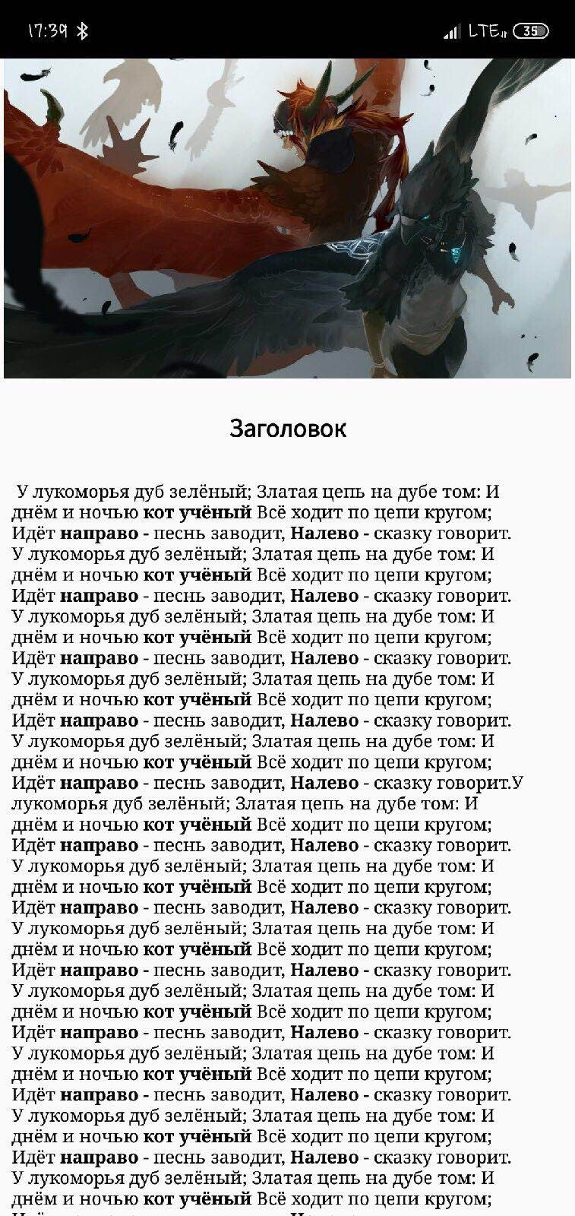


Relative code:

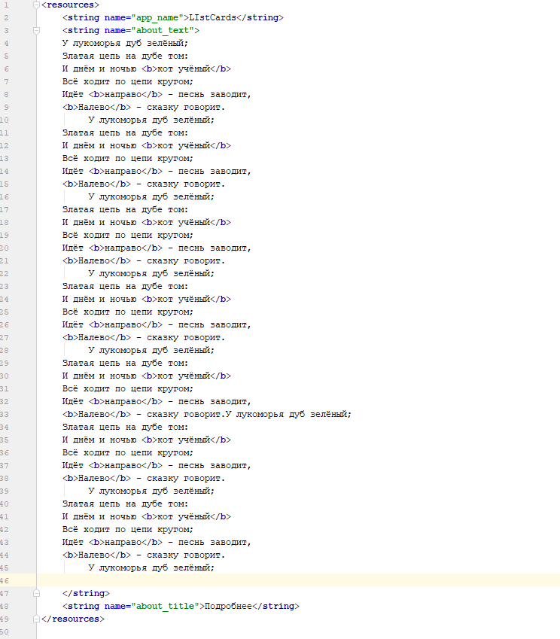

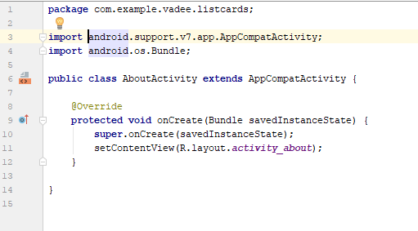
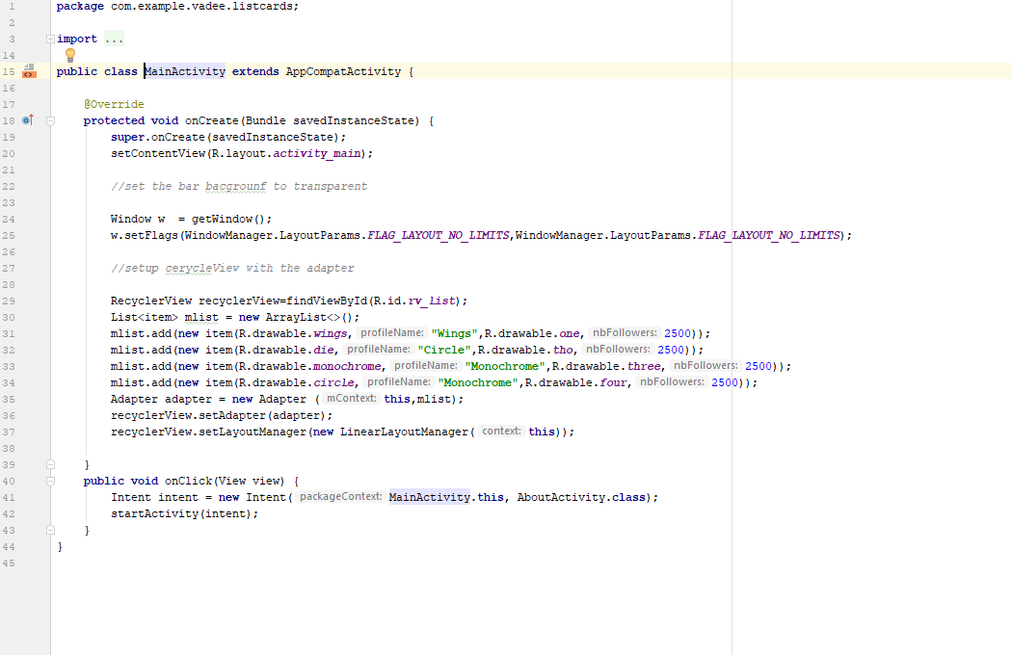

- Perspectives about object-oriented design patterns:

This project has great prospects in terms of assistance for students. You can implement the main application and dependent: 1) the Main application will be on the device at the head of the group who can edit the schedule, add news and more. 2) the dependent application will be on the device of the group students and receive all the information that comes from the main device. Also in this application, you can implement dynamic maps to help students find the right campus buildings.

